FindTutor - Final Project Report

Team 25
Kyaw Zin Lin | 6931503008
Kongpop Wechvitan | 6931503021
Kasidate Krongsawatkul | 6931503100

Github Repo
https://github.com/kiranaa1968-blip/Team-25-FindTutor

Prototype
https://www.figma.com/proto/Vlrcc2jsmar1VDT6aEywBo/FindTutor---Prototype?node-id=8-2&p=f&t=rfUrOnghULXVuYHh-1&scaling=min-zoom&content-scaling=fixed&page-id=0%3A1&starting-point-node-id=8%3A2

The Problem
There can be difficulty in finding a suitable peer tutor for specific courses since any information about students willing to tutor are usually split across social media platforms and word of mouth, and this can be much more troublesome depending on the courses they need tutoring for. As well, any students who are capable and willing to tutor don’t really have any centralized way to advertise their availability.

Users
- Students who want to find a peer tutor that has both the qualification and availability that matches their current academic needs.
- Students who want to teach other students but do not have an easy way of reaching out to potential students

Requirements Summary

ID | Requirements | Priority
FR-1 | Create a tutor profile listing courses and availability | Must
FR-2 | Search for tutors by filtering desired courses and time | Must - MVP
FR-3 | View tutor profile and see availability, what courses the tutor teaches, and reviews | Must
FR-4 | Send/Receive tutoring requests | Must
FR-5 | Leave a review | Should
NFR-1 | When a student searches for a tutor, the search results will appear within 5 seconds on campus Wi-FI | Should
NFR-2 | A tutoring request will be notified to tutor within 10 seconds on campus Wi-Fi | Should
NFR-3 | A new user should be able to search for a tutor based on a course in less than 3 steps upon opening the app | Should
NFR-4 | No duplicate profile or review is created when you try to create a new profile or review | Must
NFR-5 | When accessing a profile, user must authenticate with their password or id | Must

Design

Use-Case Diagram
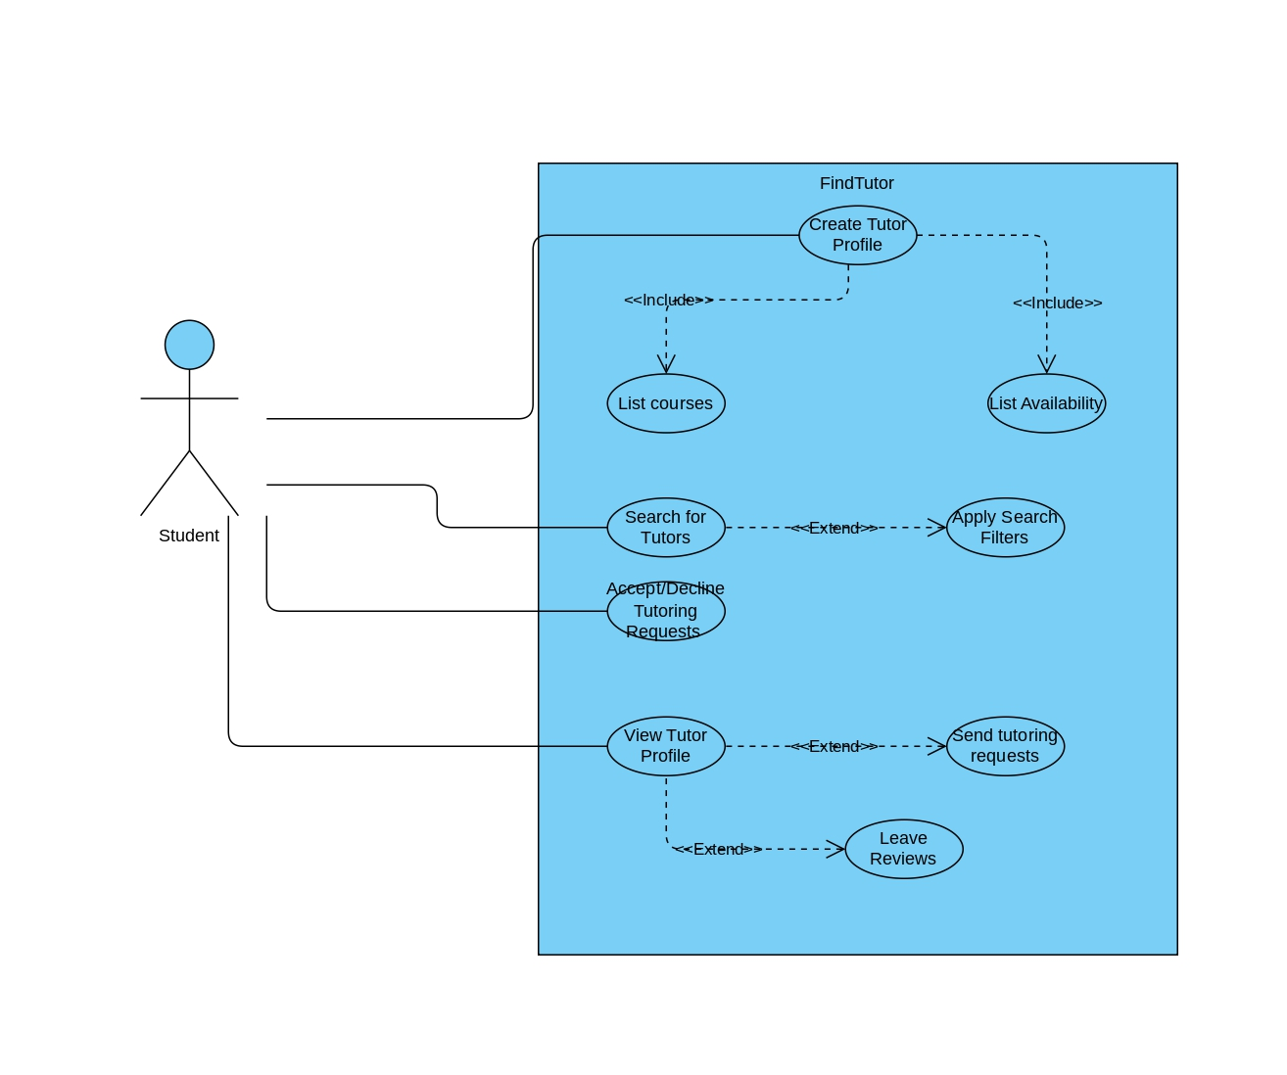

UI/UX
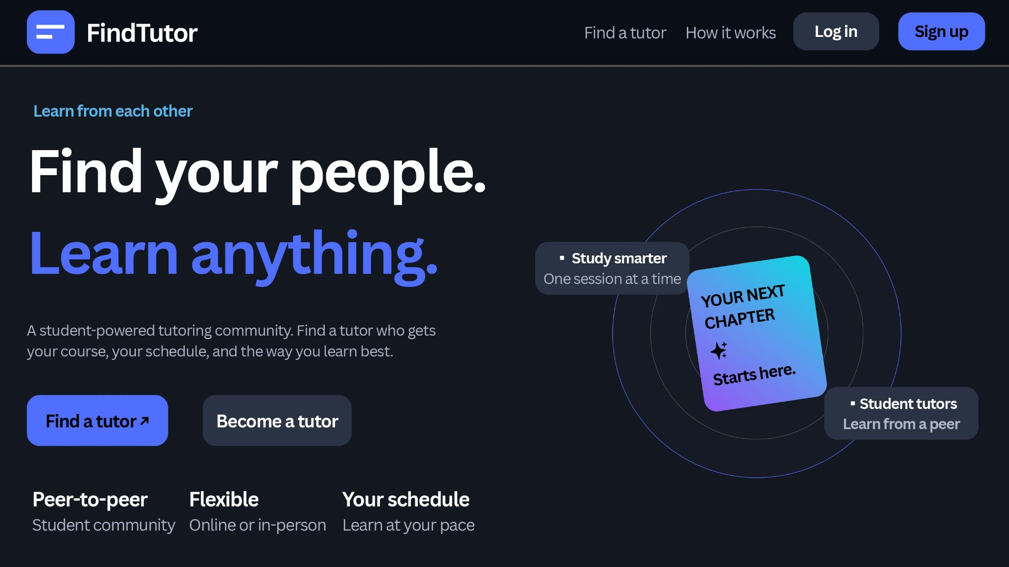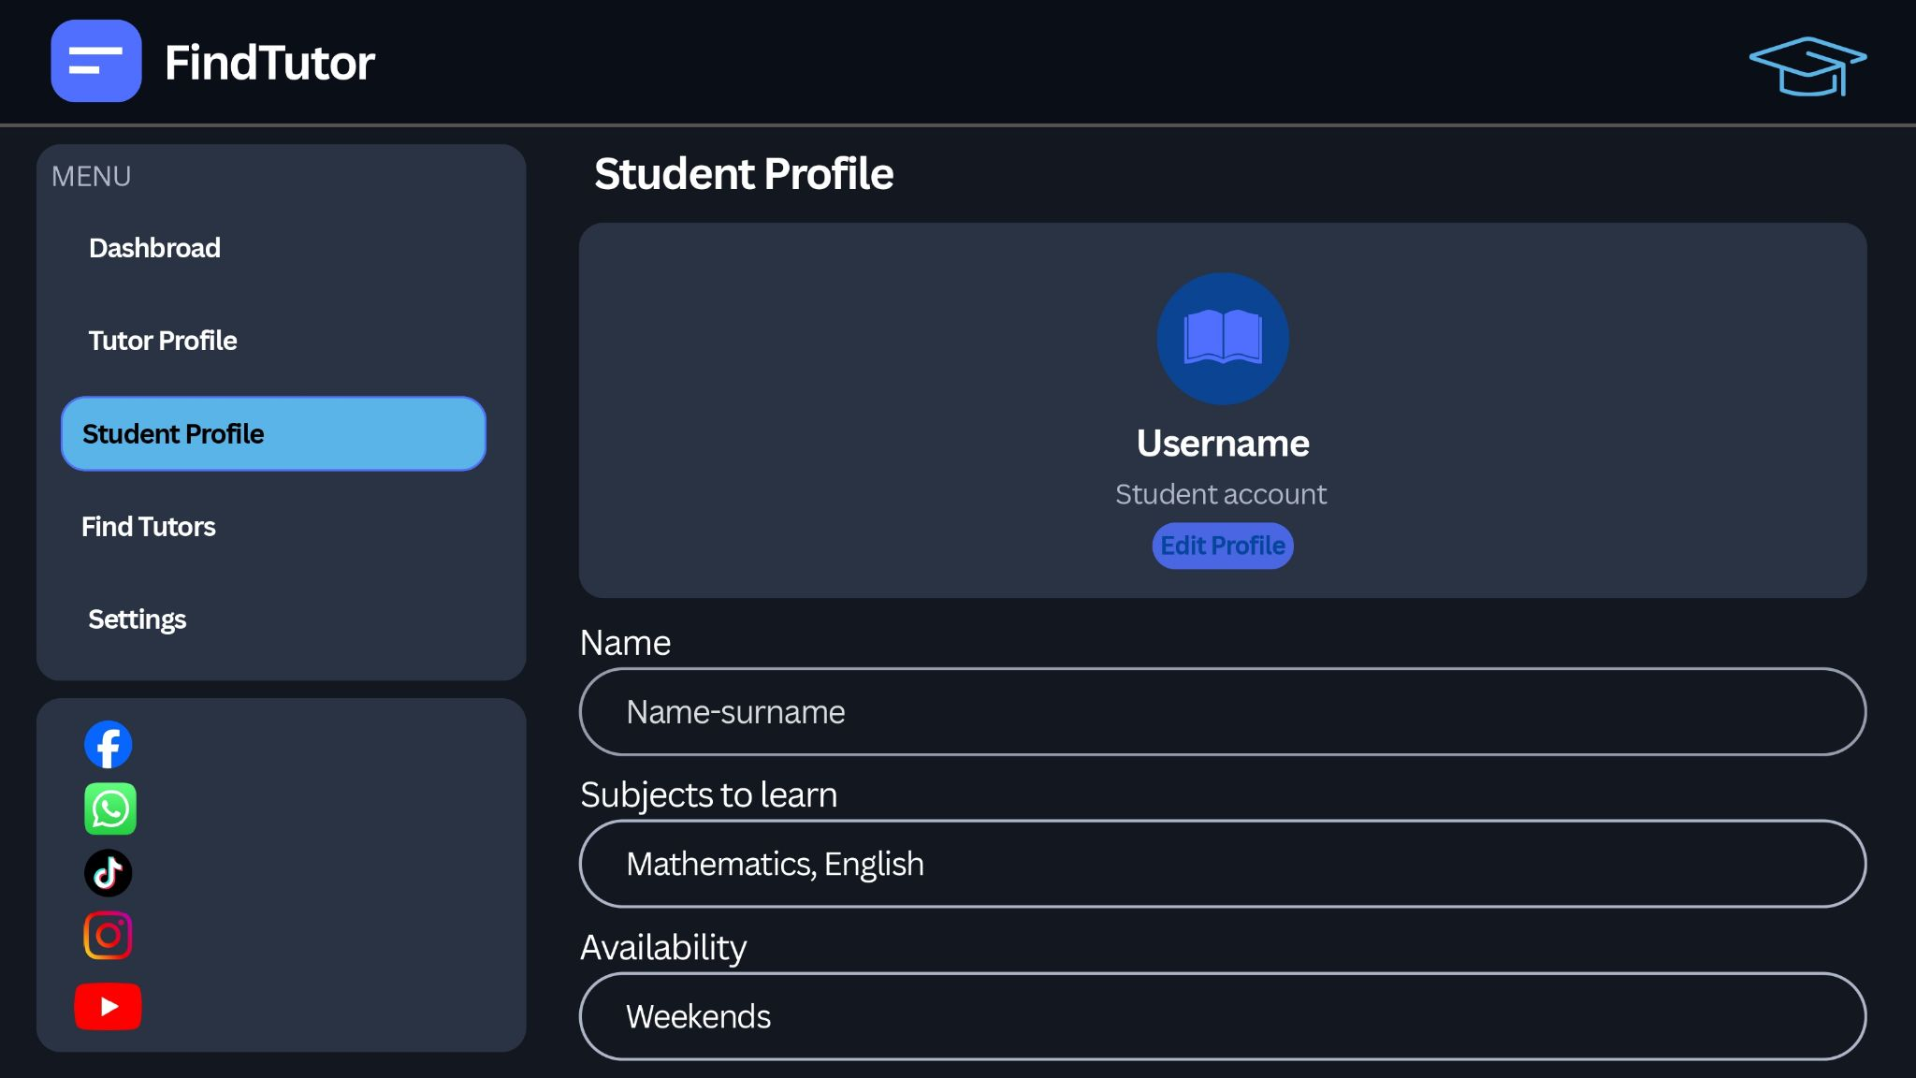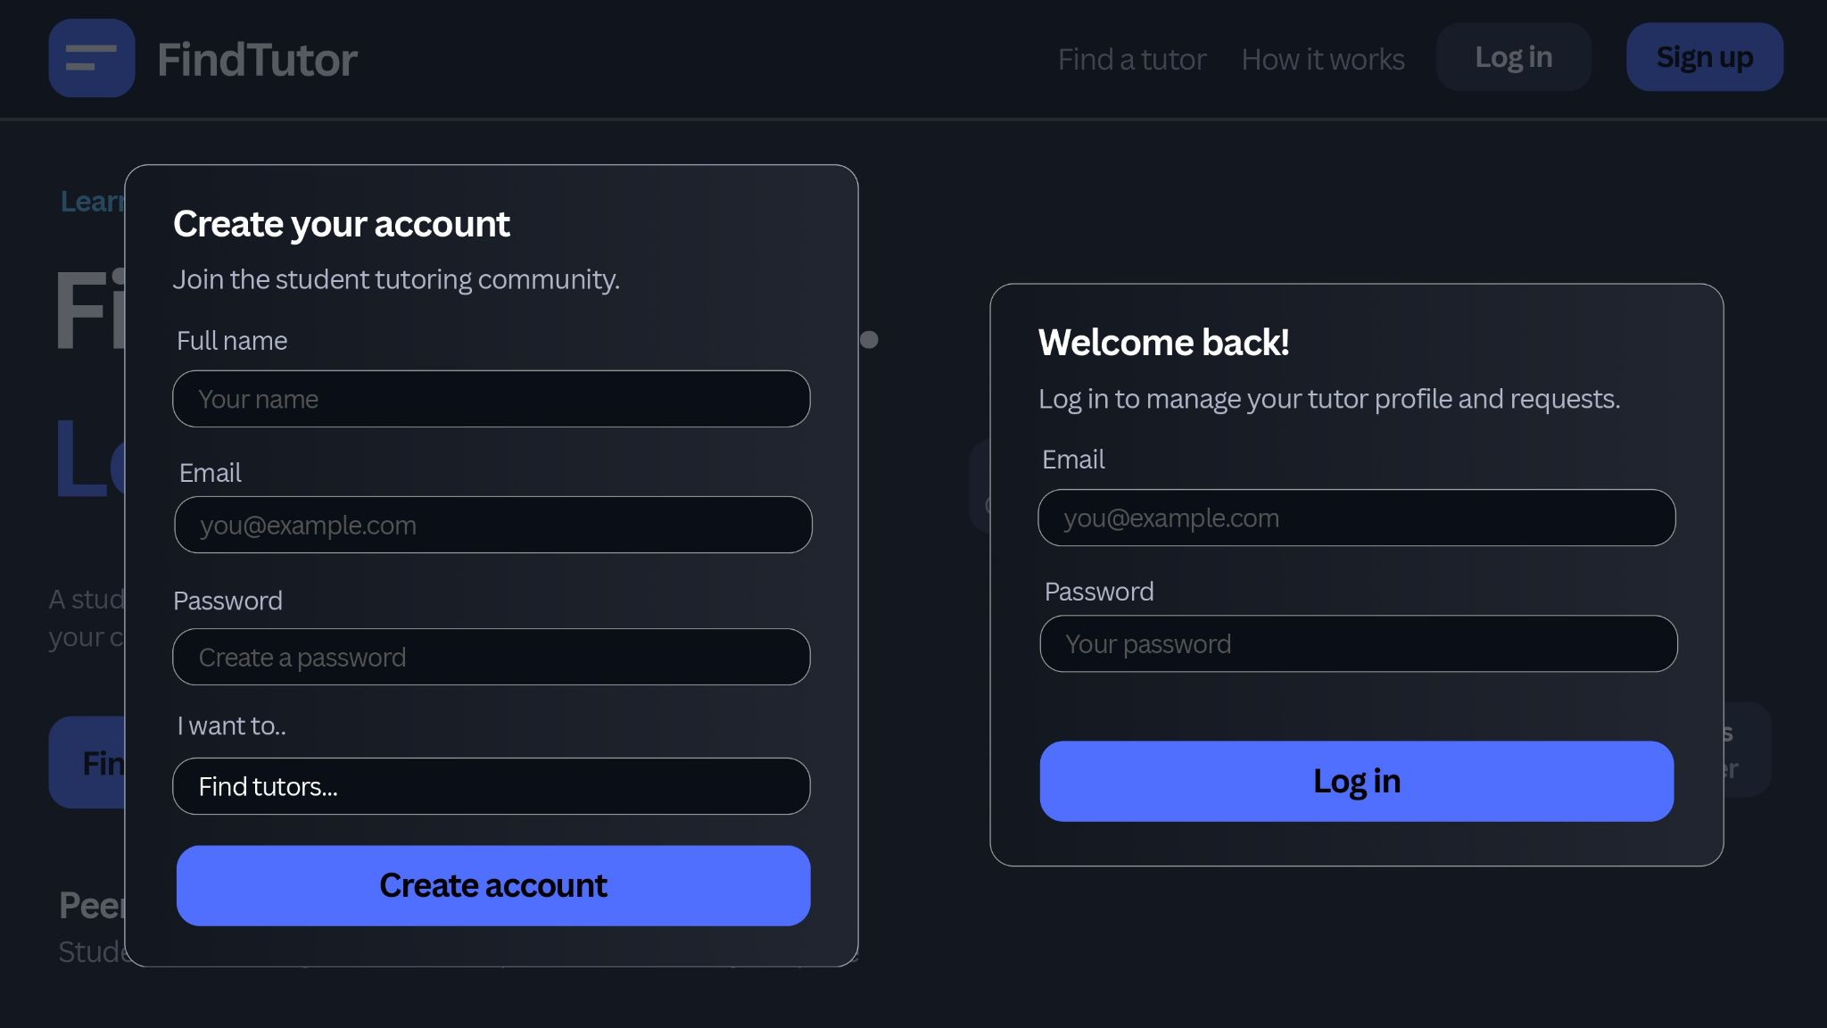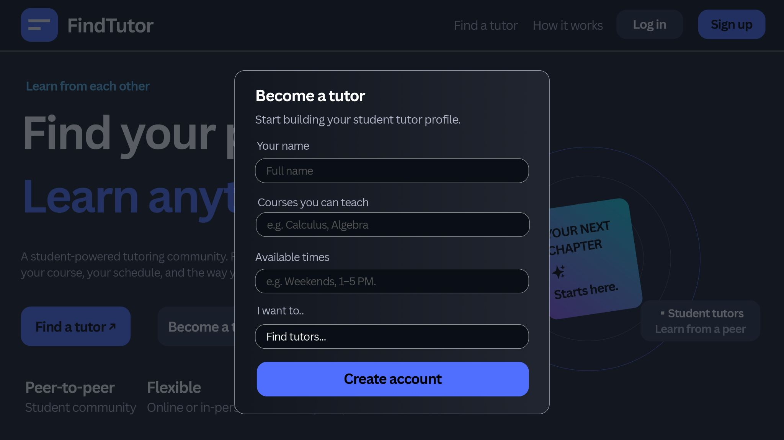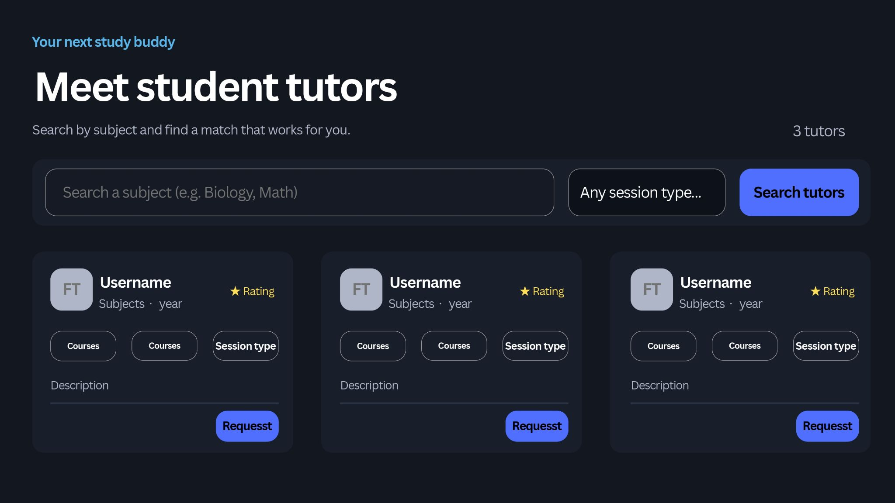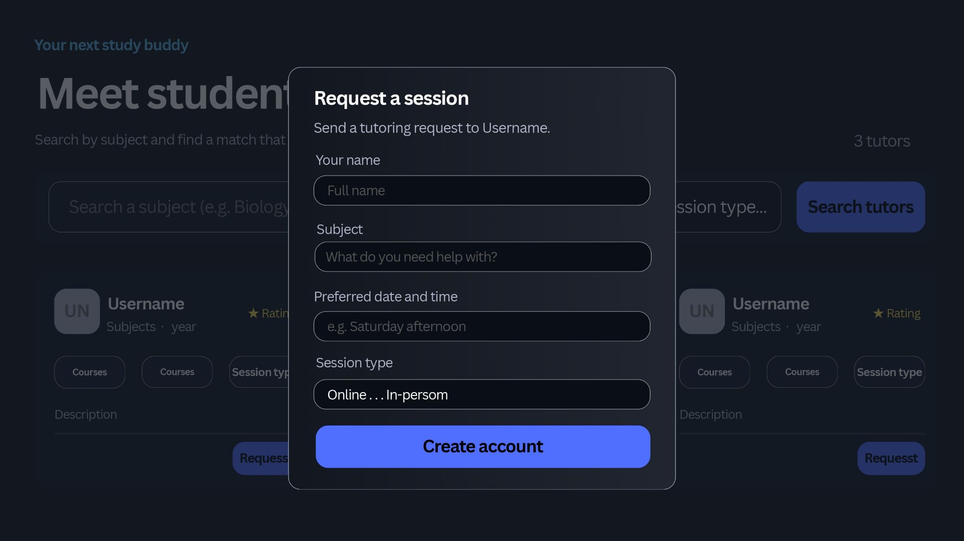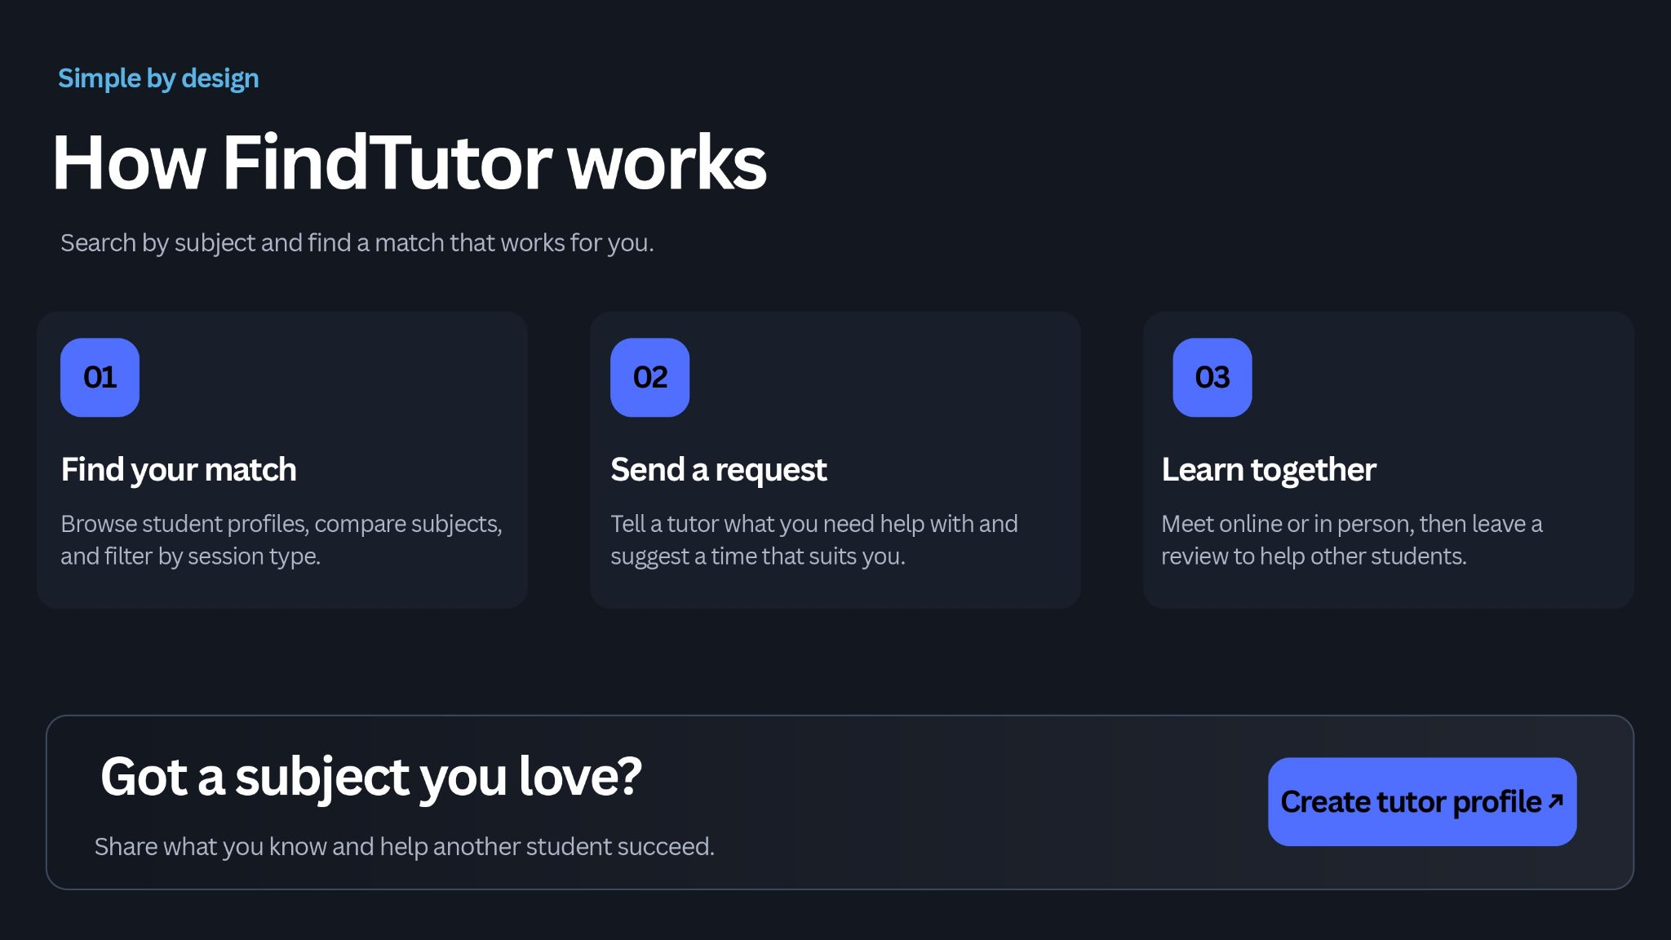

Prototype Build
Created with Figma
Prototype Link

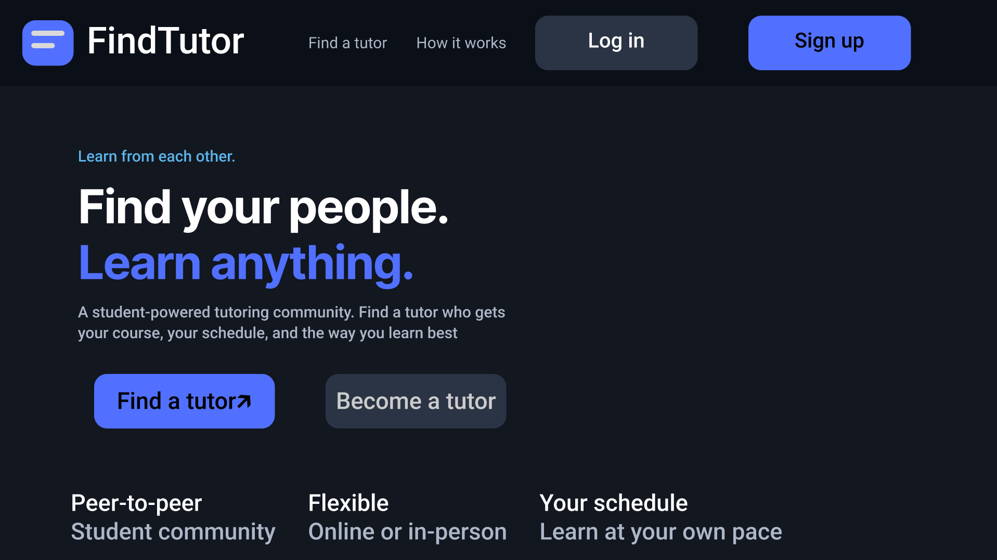
FR- 1 Create a tutor profile listing courses and availability
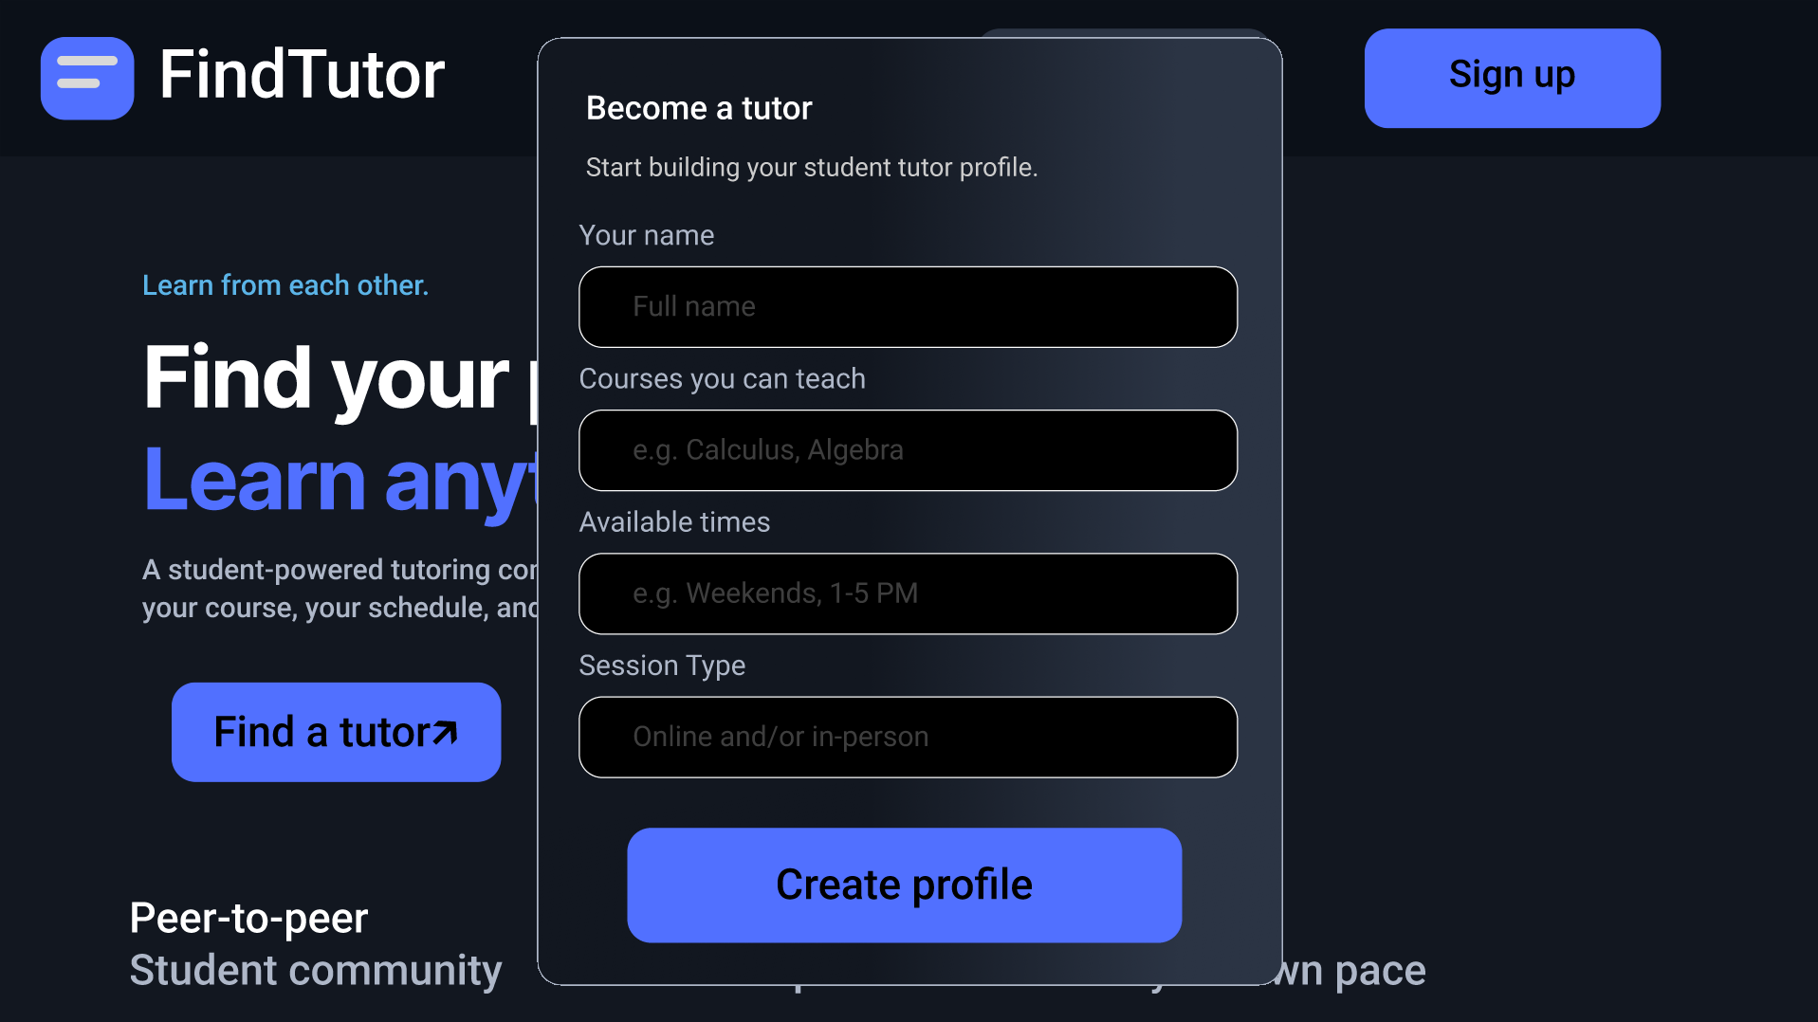

FR - 2 Search for tutors by filtering desired courses and time
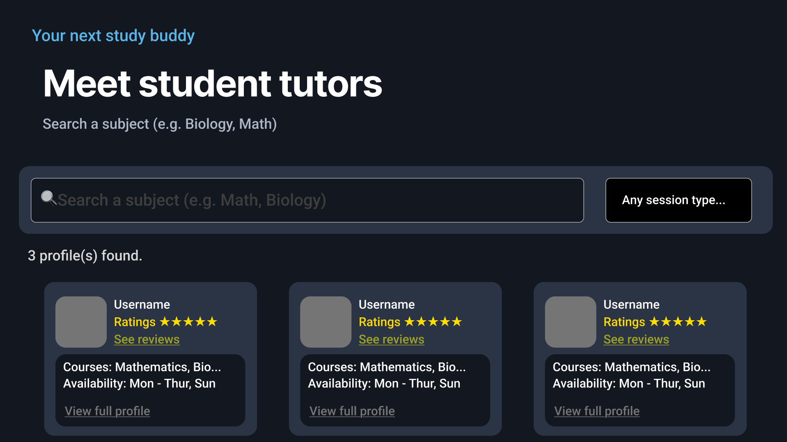
FR - 3 View tutor profile and see availability, what courses the tutor teaches, and reviews
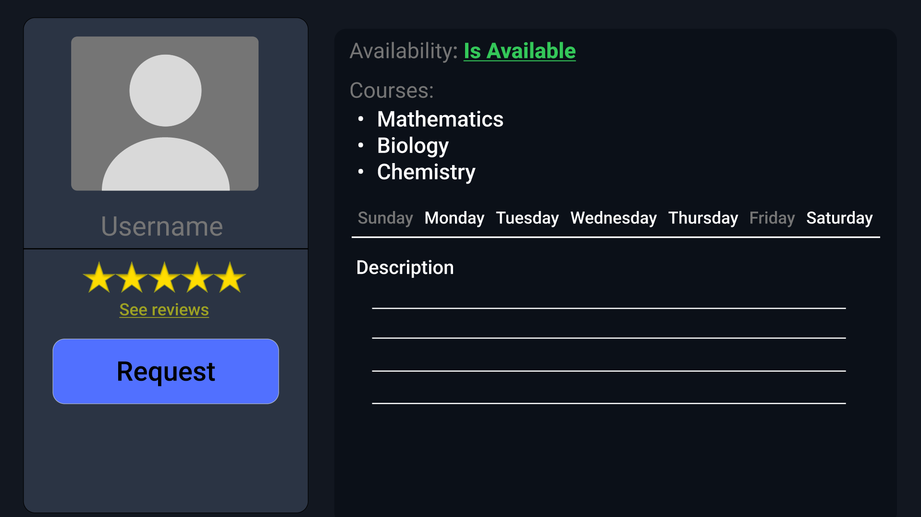
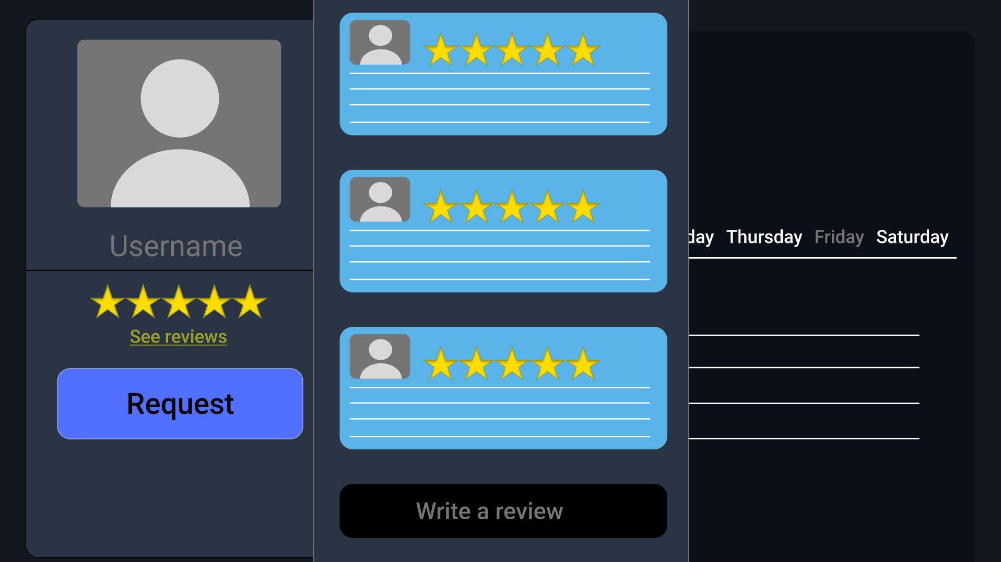
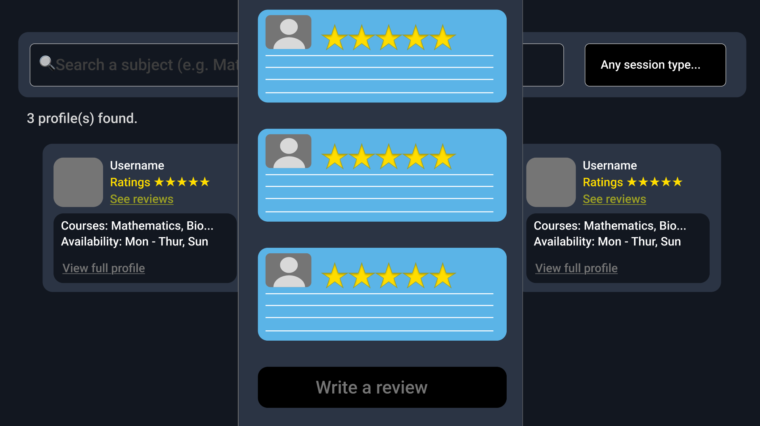
FR - 4 Send/receive tutoring requests
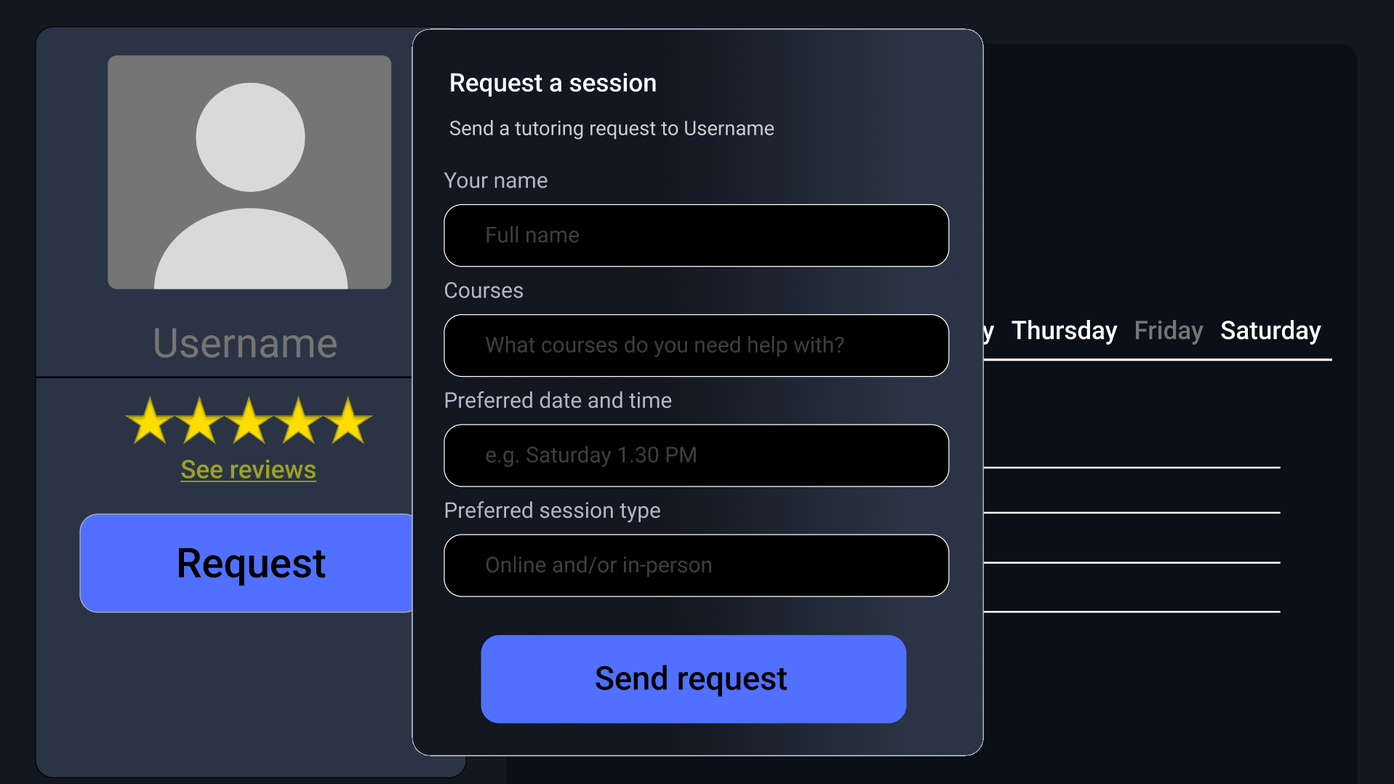
FR - 5 Leave a review
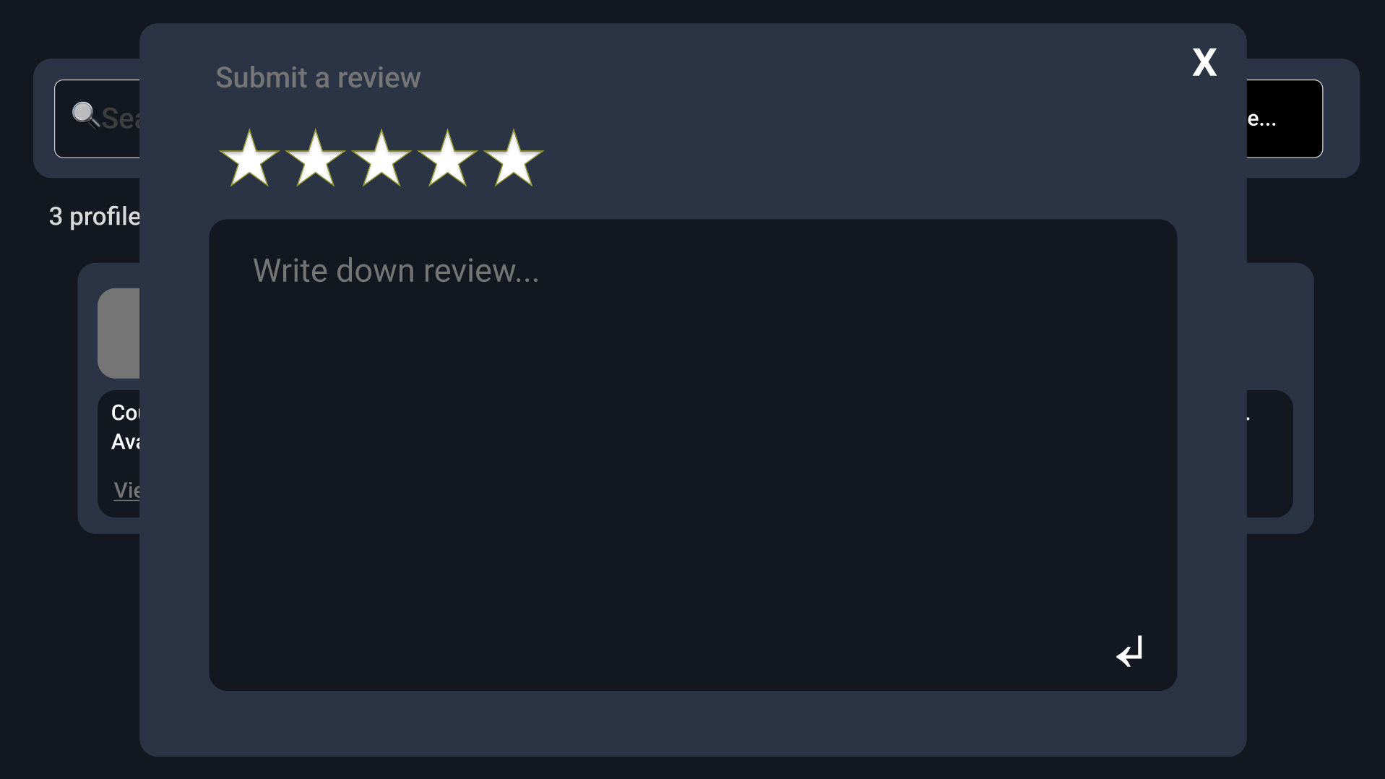

Testing

ID | Scenario | Expected | Result
(FR-1) | A tutor profile is created with valid details, courses, and availability. | The profile is created and the details are saved properly | Not tested
(FR-1) | Tutor attempts to create a profile without any courses | The tutor is prompted to select at least one courses, and the profile is not created | Not tested
(FR-1) | Tutor creates a profile with multiple courses | The profile is created and all courses that the tutor selected can be seen | Not tested
(FR-1) | Tutor creates a profile without adding/ listing any availability or time slots | The system will assume the tutor is available for everyday and will create a tutor profile with every single day listing them as available | Not tested
(FR-1) | Tutor edits their profile | The profile will be updated accordingly and no duplicate profile will be created | Not tested
(FR-2) | Student searches for Tutor with the listed course: Mathematics | Tutor with Mathematics listed will be shown to the student while those without will be hidden | Not tested
(FR-2) | Student searches for a tutor who is available during: Monday | Tutor with Monday available will be shown while those who do not will be hidden | Not tested
(FR-2) | Student searches for tutor with the listed courses: Mathematics, and is available during: Monday | Tutor with Monday available and Mathematics listed in their profile will be shown while those that do not match these criteria will not be shown | Not tested
(FR-2) | Student searches for courses and availability with no matching tutors | ‘No tutors were found’ will be displayed and no tutor profiles will be seen by the student | Not tested
(FR-2) | Student clears the search filters | The search results will be updated to reflect the current criterias | Not tested
(FR-3) | Student open a tutor profile | The profile will be displayed along with the details the tutor has listed | Not tested
(FR-3) | Student views a tutor profile with reviews | The reviews will be displayed to the student | Not tested
(FR-3) | Student views a tutor profile with no reviews | No reviews will be displayed to the student | Not tested
(FR-4) | Student sends a tutoring request | The request is created and will be sent upon the student’s confirmation | Not tested
(FR-4) | The tutor receives the request | The tutoring request will be sent to the tutor and the student can not send another request | Not tested
(FR-4) | The tutor accepts the request | The student will be notified that the request is accepted, they will be able to contact the tutor and they cannot send another request | Not tested
(FR-4) | The tutor declines the request | The student will be notified that the request is declined and the student will not be able to send another request for the next 5 minutes | Not tested
(FR-4) | The student attempts to send another request to the tutor | The request will not be sent and the student will be notified of this | Not tested
(FR-4) | The student attempts to send another request after being declined but 5 minutes have not passed | The request will not be sent and the student will be notified of this and the remaining time until they can send another request | Not tested
(FR-5) | Eligible student submits a valid review | The review is saved and displayed on the profile | Not tested
(FR-5) | Student attempts to submit a review without writing anything down | The review is not submitted and the student is prompted to complete it | Not tested
(FR-5) | Student attempts to submit a review to the same tutor | A duplicate review will be created | Not tested
(FR-5) | An ineligible student attempts to write a review | A message will be displayed to the student that they will not be able to write a review | Not tested
(FR-5) | The student views the profile after writing the review | The review will be seen by the student | Not tested

AI-First Reflection
In this project, we used: ChatGPT.
We first used ChatGPT to help create our first project: BusBuddy, however we had to change to a different project due to the fact we did not understand the problem and it was shallow at best. ChatGPT was also used to correct any grammar mistakes and fix wordings to sound much more professional. AI was also used in the layout for UI/UX to help us design the UI to place the FRs where the user can easily spot it and won’t be confused when navigating our website. ChatGPT was also in the Golden Thread Table for the design and implementation section to explain the definition of both of these.

Golden Thread Table

Problem | Requirement | Design | Implementation | Test scenario/Acceptance criteria
Students have trouble in finding a peer tutor | FR-2 | Screen search + filters wireframe | Search function + course and time filter | Students will only see tutors who have the matching courses and time listed in their profile ❌
Tutors need a way to reach out to other students and advertise their services | FR-1 | Profile creation overlay | Create profile + save tutor details | Create profile with courses and availability + profile is saved and displayed correctly ❌
Students need a way to know if the tutor is qualified or not | FR-3 | Courses, availability data model + review overlay | Profile page displayed detailing listed courses, availability, and reviews | Open profile → The details listed by the tutor (Courses and availability) + Reviews will be displayed❌
Students want a way to request a tutoring session from a tutor | FR-4 | Tutoring request overlay + request status flow | Send request + receive and respond to requests | Students send request → Tutor receives the request and can accept or decline it❌
Students need a way to share feedback about tutors | FR-5 | Review submission overlay | Review form + save/display functionality | Submit review → review appears on tutor profile ❌

Links

Github Repo: Repo

Prototype: Figma Prototype

